DEPLOYMENT

MENU

**COSCAN**





**Table of Contents**

Introduction

System Requirements Installation Procedures Cloning Git Repository Starting the Server

Machine Learning API Deployment Feedback and Version Information

**INTRODUCTION**

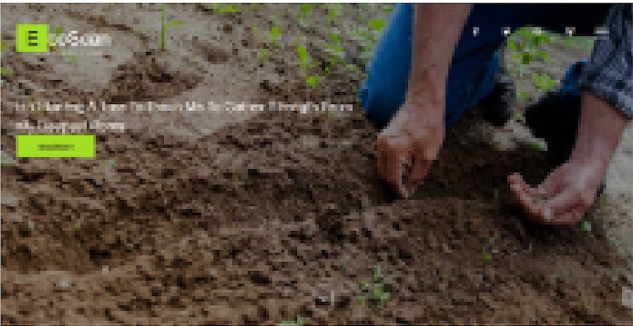Welcome to the deployment manual for the Leaf

Disease Detection System, also known as ''Eco Scan". This document provides a step-by-step guide for successfully deploying our software in your

environment. It is intended for developers, advanced users, and system administrators.

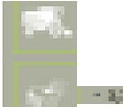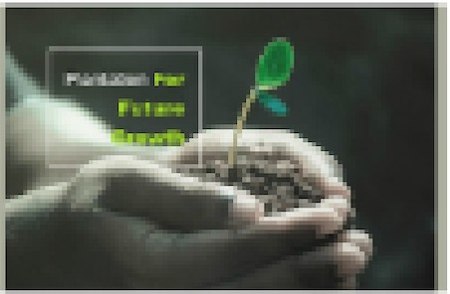

.,...,

......

* I

In this manual, we will cover the following topics:

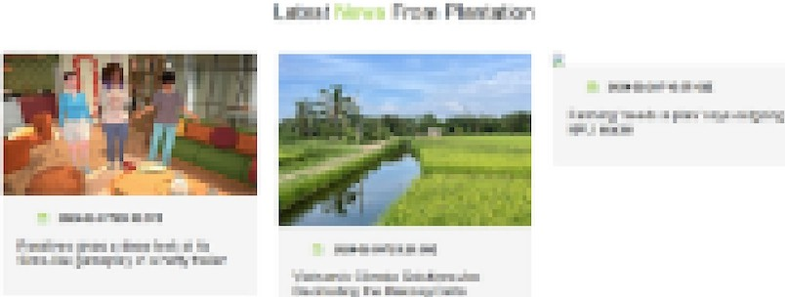System Requirements - hardware and software requirements:

* Installation Procedures - step-by-step guide to install the software
* 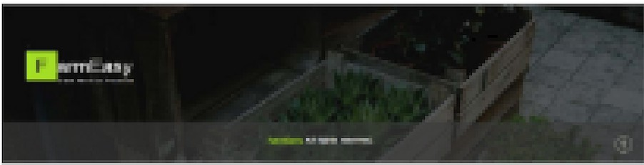Troubleshooting - common errors and issues that may arise
* Support and Resources - links to related resources for better understanding our stack



## SYSTEM REQUIREMENTS

Hardware Requirements (Desktop)

* + Processor (CPU): Equivalent to AMO Ryzen 3 2.4Ghz (4-core)

/ Intel Core i3 2.6Ghz (4-core)

* + Memory (RAM): Minimum 8 GB DDR4
  + Storage: 10 GB SSD space for optimal performance
  + GPU: Intel Iris Xe/ Radeon Graphics
  + Screen Resolution:1920 x 1080
  + Network Connectivity: Minimum download speed of 10 Mbps

Software Requirements (Desktop)

* + Operating System: Windows 10/11, macOS Big Sur or later, Ubu ntu 20.04 LTS or later
  + Web Browser: Google Chrome, Mozilla Firefox, Microsoft Edge (latest versions)

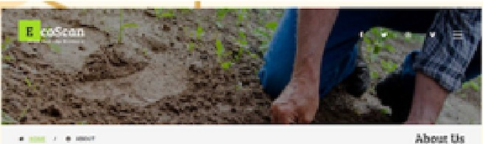 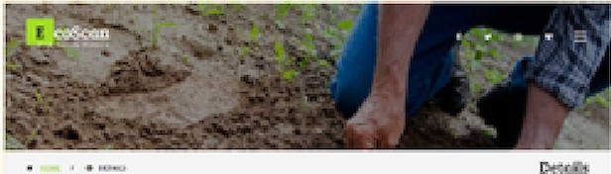

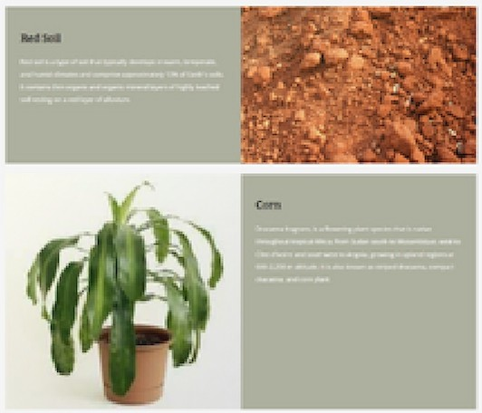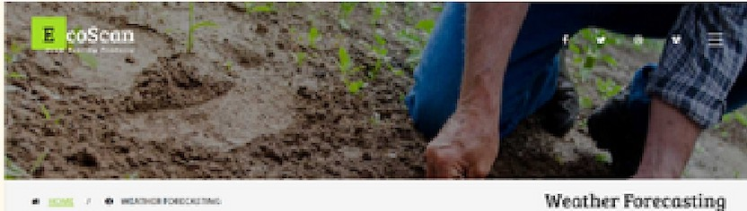"' Cl



Agticulrurit Nol OclyGh,,.-..1 JUclw.lTo A MlfflOtl, lllu1tbi:

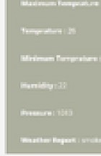

...........

0-:,Jy Rld1rt :U.f! Ccl11Call H.frOwni



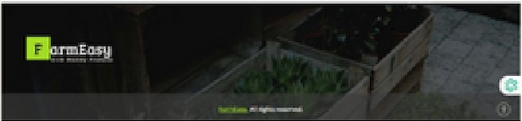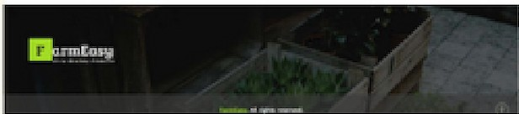11,nnEOS]l

,.. ...-

# INSTALLATION PROCEDURES

l. Install Visual Studio Code (VS Code)

* Download VS Code from httP-s:Ucode.visualstudio.com/
* Run the installer and follow the on-screen instructions
* Launch VS Code from the application menu or desktop shortcut

1. Install Node.js and npm
   * Download Node.js LTS version from httP-s:Unodejs.orgL
   * Run the installer with default settings
   * Verify installation by running node -v and npm -v in the terminal

Cloning Git Repository

l.Open a terminal or command prompt

1. Navigate to the directory where you want to clone the repository
2. Run the following command: https://gith ub.com/EcoSca nTea m/LeafDiseaseDetection.git

Change into the cloned repository directory

**Usemame:**

**Register**

**Login1**

Re,iuired. 1SQ characters 0:1 fewer. l"tters. digit, and

*@/l+l-1.* o"l'y.

Username: ,i_,ser Passwmd':

Password:

-

* Yom pas word can'! be too simil..r **10** you, oti'ler poaon;I inlormAtion.
* Your pa!sword rnui1c0M i11M INM 8 diaratter
* Your password <M1 be ., commonly 1.1!: d

**pa':51Sword.**

* Your password c n'! be <!n'li1ely numetic.

Not registered ye.t' Register here

**Pas WQ•d con 1rna1tion:**

Ente, the same



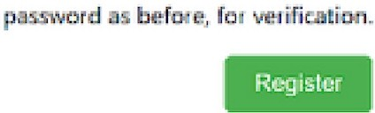

Alre.idy a user? login ner <?



## STARTING THE SERVER

l.Open a new terminal in VS Code

1. Run npm install to install dependencies
2. Run n pm start to start the server
3. Scan the displayed QR code with Expo Go (Android) or Camera app (iOS) to launch the app

Machine Learning API Deployment

l.Create a new web service on Render (https://render.com/)

2.Connect to the repository containing the detection API 3.Configure the deployment settings:

1. Environment: Python 3
2. Build Command: pip install -r requirements.txt
3. Start Command: uvicorn model_APl:app --host 0.0.0.0 --por 10000

4.Deploy the web service and monitor the deployment process ir the Logs

# FEEDBACK & VERSION INFORMATION

Version: 7.0 Release Date: May l, 2024

We value your feedback for improving the deployment process and the Leaf Disease Detection System. Please share your thoughts, suggestions, or report any issues encountered during deployment.

Contact: [suP-P-Ort@ecoscan.com](mailto:suP-P-Ort@ecoscan.com)

